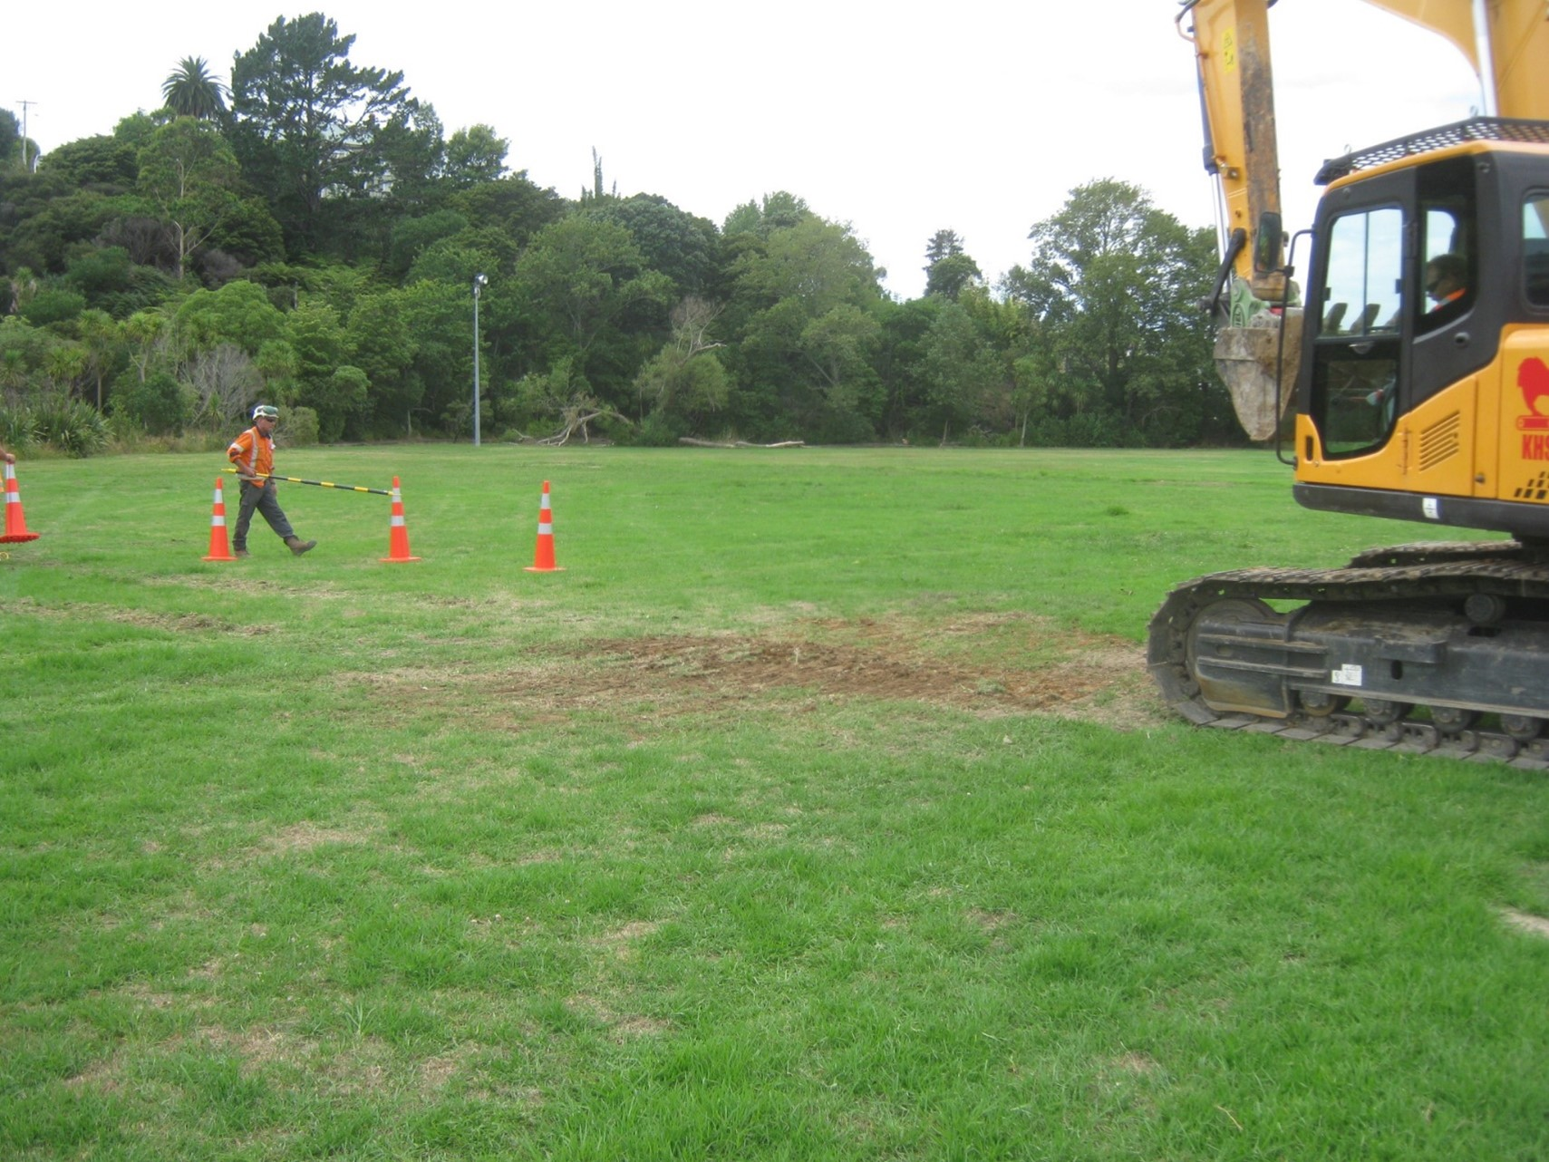


NZGS Specification

NZGS_0100P PRELIMINARY AND GENERAL Project Specific Specification
Version 0.2 - 24/08/2022
Document Status
Version | Date | Purpose | Status
0.2 | August 2022 | Member consultation | Draft
0.1 | June 2022 | Committee and peer review | Draft
The document may be updated from time to time following the issue date. The latest version is available from the New Zealand Geotechnical Society (NZGS) website www.nzgs.org
About the New Zealand Geotechnical Society
The New Zealand Geotechnical Society (NZGS) is the affiliated organisation in New Zealand of the International Societies representing practitioners in Soil Mechanics, Rock Mechanics and Engineering Geology. NZGS is also a collaborating Technical Society of Engineering New Zealand.
Copyright
This work is licensed under the Creative Commons Attribution 3.0 New Zealand License. To view a copy of this license, visit http://creativecommons.org/licenses/by/3.0/nz/
You are free to share (copy and redistribute the material in any medium or format) or adapt (remix, transform, and build upon the material) for any purpose, even commercially. You must give appropriate credit, provide a link to the license, and indicate if changes were made. You may do so in any reasonable manner, but not in any way that suggests the licensor endorses you or your use. You may not apply legal terms or technological measures that legally restrict others from doing anything the license permits. No warranties are given. The license may not give you all of the permissions necessary for your intended use.
Limitations
While care has been taken in preparing this document it remains a guide and, when used, does not relieve any person of the obligation to consider any matter to which that information relates, according to the circumstances of the case. All users should satisfy themselves as to the applicability of the content and should not act on the basis of any matter contained in this document without considering, and if necessary, taking appropriate professional advice. NZGS does not provide any warranty as to the accuracy or completeness of this document or its fitness for any particular purpose. NZGS shall not incur any liability arising out of the use of this document.

Foreword
This Project-Specific Specification has been developed to be used exclusively with the other components of the NZGS Specification series, notably:
    - NZGS_000 Standard Specifications User Guide
    - NZGS_100 Preliminary and general
    - NZGS_110 Method of measurement
    - NZGS_200 Ground Investigations
    - NZGS_510 Earthworks
Acknowledgements
This document was developed by a volunteer subcommittee from the volunteers of the NZS4431 working group comprising Ross Roberts, William Gray, Tony Kao, Tim Farrant, Guy Forrest, Chris Massey, Barbara Rouse, Andrew Rose, Sally Hargraves, Tony Fairclough, Simon Barber, Mark Stringer, and Ali Shokri.

Table of contents
NZGS_100P.1 Amended clauses 4
NZGS_100P.1.1 Clause XX 4
NZGS_100P.1.2 Clause XX 4
NZGS_100P.2 Additional clauses 5
NZGS_100P.2.1 Cause XX 5
NZGS_100P.2.2 Clause XX 5

Amended clauses
The Geotechnical Designer shall document below all changes required to the standard clauses given in Specification NZGS_100:

Clause XX
Describe change here

Clause XX
Describe change here

Additional clauses
The Geotechnical Designer shall document below all clauses required in addition to the standard clauses given in Specification NZGS_100:

Cause XX
Document new clause here

Clause XX
Document new clause here

Currently presented as Volume 1 of the New Zealand Ground Investigation Specification, NZGS 2017

