Time-history validation of simplified design approach for shear piles subject to liquefaction induced lateral spread with evacuation
M Neves & D Yang
Tonkin & Taylor Pty, Australia.
A Naylor
Tonkin & Taylor Ltd., Auckland.
ABSTRACT
The lateral load transfer between a pile and laterally spreading ground during an earthquake is a complex soil-structure interaction problem given the significant nonlinear behaviour of soils during such an event. This interaction becomes more complex when piles are used as a retaining system in close proximity to a free face/slope (e.g. river beds and coastal areas), which will likely suffer evacuation during an earthquake.
Common practice design methods rely on an iterative procedure which combines the Newmark Sliding Block theory and Limit Equilibrium analysis to predict the permanent soil displacements and yield accelerations of the slope. This is usually followed by the use of specialized piling/retaining wall software to ensure strain compatibility is reached. However, this approach needs to be adapted to consider the detrimental effects of evacuation on the mobilised shear forces and bending moments within the pile.
To validate previous adaptations to the commonly accepted approach, time-history analyses have been undertaken on a range of selected earthquakes. The finite element (FE) modelling abandons the Newmark Sliding Block premise of a rigid soil block movement and enables a more accurate prediction of the likely evacuation profile in a post-seismic scenario. Furthermore, it provides a range of likely displacement for the piles, together with an envelope of structural forces to be accommodated by the structural design of the reinforcing elements. This paper discusses the assumptions and outcomes of the FE and presents a comparison between the FE and the modified pseudo-static design approaches.

INTRODUCTION AND BACKGROUND
Liquefaction-induced lateral spread typically involves the lateral displacement of large and relatively intact blocks of soil down gentle slopes or towards a free face, such as a waterfront or riverbank. It occurs as a result of liquefaction of relatively shallow underlying strata during a seismic event and movement of non-liquefied material above the liquefied layer. It can be a major cause of damage to infrastructure located near waterfronts during and potentially after earthquakes. These displacements are usually permanent and range from a few centimetres to a few meters.
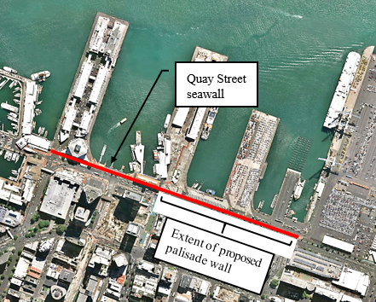
In New Zealand, Auckland Transport have decided to upgrade the resilience of Auckland City’s waterfront, as part of the Auckland Downtown Infrastructure Development. This includes an existing seawall, which provides support to the Quay Street carriageway, footpaths, as well as a large number of buried utility services and provides access to the Ferry Building and Auckland’s port (Figure 1). The existing ground conditions at this location comprise reclamation fill overlying Upper Tauranga Group marine and Lower Tauranga Group alluvial sediments, which in turn overly East Coast Bays Formation (ECBF) material. During Ultimate Limit State (ULS) levels of shacking, sandy materials within the reclamation fill, and isolated lenses within the Upper Tauranga Group (UTG) are considered susceptible to liquefaction, with the remaining fine-grained horizons within both strata considered susceptible to cyclic strength loss. Limit equilibrium (LE) analysis has suggested that lateral spreading is likely to occur, following the triggering of liquefaction and cyclic softening, due to propagation of a slip surface between liquefied and cyclically softened lenses of the UTG sediments.
Figure 1: Site location plan [Auckland Council, 2020]
To reduce lateral spread induced damage, a reinforced concrete palisade wall is proposed along a circa 300m section of the Quay Street seawall which is to be built landward of the existing seawall (Figure 2), due to infrastructure and environmental constraints, as well as the historic/heritage value of the latter. Nevertheless, a key consideration in the design was that the existing seawall would be allowed to potentially fail, during the design earthquake event, leaving the proposed palisade wall to act as a retaining solution to limit the horizontal displacements at the surface. Along the remaining length of the seawall, a solution comprising a series of jet grout shear walls has been proposed to provide the necessary support to Quay Street, as documented in Neves et al. (2020).
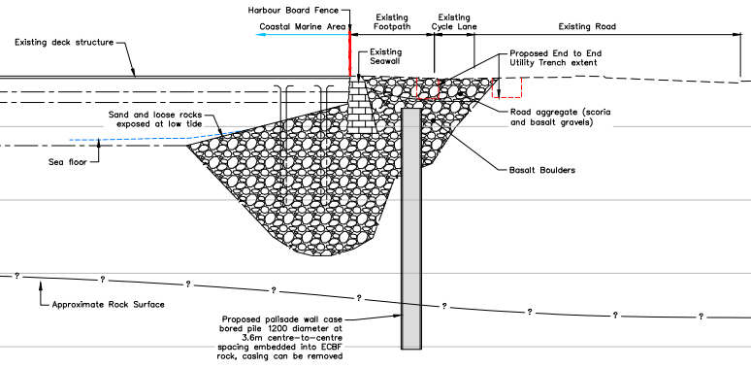
Neves and Naylor (2020) provide an overview of the simplified methodology that has been developed for the design of piled walls subject to lateral soil movement, combined with an evacuation scenario. The proposed approach makes use of readily available software, whilst ensuring displacement compatibility between the required shear forces to meet overall stability requirements and the predicted soil/pile displacements.
Figure 2: Typical cross section of the proposed palisade wall
To validate this approach, and especially given the importance level of the works, finite element (FE) time-history analyses have been undertaken on a range of scaled earthquake records using the software package PLAXIS 2D. The selection of the appropriate records is outwith of the scope of this paper, however they have been based on a 1D site response analysis, undertaken to determine the effect of the site-specific superficial soils on the ground motion. Ahead of the FE analysis, a selection and scaling of input ground motions, as well as the 1D site response analysis, was completed to confirm the peak ground acceleration (PGA) for liquefaction analysis and for the geotechnical design Quay Street strengthening structures.
This paper summarises the validation of the simplified design approach when applied to one particular design cross section along the seawall. Nevertheless, the authors of this paper have confirmed the applicability of the method to the remaining design cross sections.

Time-History analyses

Methodology
The design approach to the time-history analyses has generally followed two separate stages:
- Calibration stage – to arrive at spectral accelerations at rockhead consistent to the subsoil classification of the site; and
- Design stage – to determine the performance of the proposed works for a range of soil conditions.
However, it should be noted that the dynamic analyses undertaken as part of this paper are not based on effective stress principles, i.e., a fully coupled effective stress method has not been used to account for excess pore water pressure, flow of pore water through the soil and detailed modelling of the stress-strain behaviour of soil. Alternatively, un-coupled analyses have been undertaken on two separate scenarios:
- Time history analysis for the proposed works with full strength soil parameters; and
- Time history analysis for the proposed works with fully liquefied/cyclic softened conditions.
The rationale behind the above was the uncertainty with regards to the point in the time history at which the subsoils lose strength due to liquefaction and cyclic softening. Therefore, by analysing these two extreme scenarios, upper and lower bound values of the evacuation likely to occur during a seismic event, as well as the structural forces in the palisade wall piles, are estimated.

Assumptions
In order to better capture the strain-shear modulus relationship of the different soils, the hardening soil (HS) small strain soil constitutive model has been chosen for the majority of the subsoils in analysis, with the exception of the seawall itself and the liquefied sandy subsoils. For the latter, a Mohr-Coulomb soil material model has been assumed, with a 1MPa undrained Young’s modulus and maximum shear strengths of 7kPa.
According to Idriss and Boulanger (2008), the magnitude of strain or ground displacement that will reduce a clay’s undrained shear strength to its residual value is difficult to assess and will depend on its sensitivity. For the fine-grained materials in analysis, and susceptible to cyclic softening, a reduction in their undrained shear strength to 80% of their peak has been adopted as suggested by Robertson and Cabal (2015). A reduction to 80% of peak for fine-grained material has been considered adequate given the seismic environment of Auckland, with the materials not cyclically softening further towards residual strength, given that these have been classified as relatively insensitive (average sensitivity of 3) in accordance with Idriss and Boulanger (2008).
As mentioned in Section 1, the selection of the appropriate earthquake records has been based on a 1D site response analysis. A number of parameters were considered in the ground motions selection, which included shear wave velocities, ground motion records from normal faulting earthquakes and New Zealand specific ground motion records, where available.
For the purpose of this paper the Pacific Earthquake Engineering Research Center (PEER) records summarised in Table 1 and Figure 3 have been used in the time history analyses.
Table 1: Selected ground motion records for time history analysis.
PEER Record Number | Earthquake Name | Scale Factor 2500yr |  | Magnitude
479 | Lazio-Abruzzo_Italy | 2.82 |  | 5.8
3624 | Taiwan SMART1(33) | 2.19 |  | 5.8
3861 | Chi-Chi_Taiwan-05 | 2.06 |  | 6.2
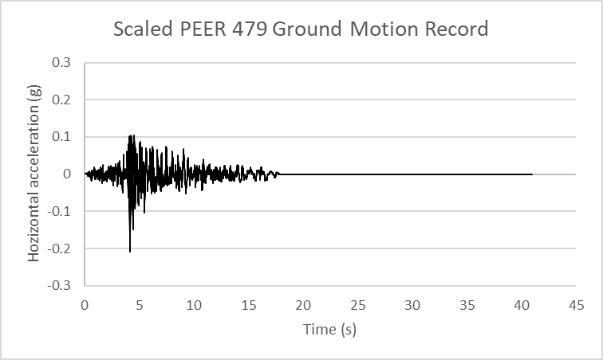 |  |  | 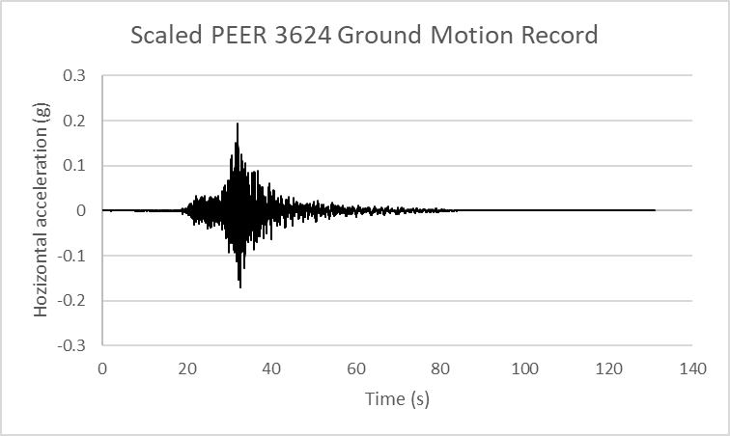
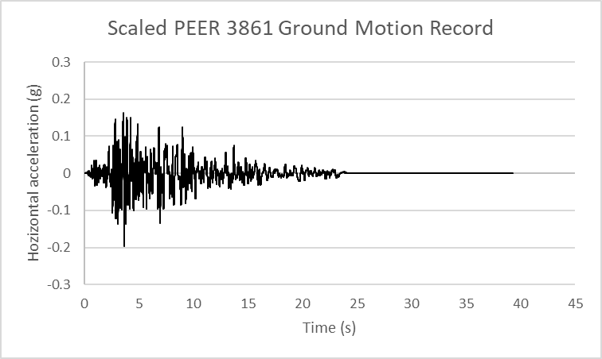
Figure 3: Selected scaled ground motion records for time history analysis
To optimise analysis time, and since the selected earthquake records have tail ends with circa null acceleration, these have been shortened to optimise analysis time. Each of the scaled earthquake records has been introduced at the base of the FE models and allowed to freely amplify within it, with horizontal accelerations at both surface and rockhead levels monitored throughout the time history analysis.
For the calibration procedure, it has also been assumed, at rockhead level, a site subsoil classification of Class B is appropriate for design, in accordance with the Bridge Manual (NZTA 2016). As a result, the earthquake records listed above, and applied at the bottom of the FE models, have been scaled to ensure that the measured horizontal accelerations at rockhead level were consistent with a Class B subsoil response.

Calibration
The calibration exercise has mostly comprised of an iterative process of discretely adjusting the scaling factor of each earthquake record, at each design cross section of analysis, and measuring how the motion amplifies through the model. To minimise the effect of the presence of the seawall on this calibration procedure, monitoring points a minimum of 50m away from the seawall have been used in the numerical models. Figure 4 illustrates a typical output of horizontal acceleration at the base of the model and at rockhead and for one particular earthquake record at one of the design sections.
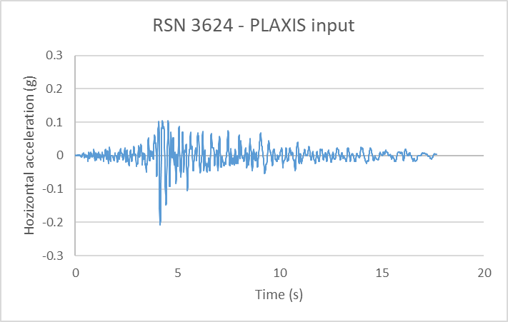 | 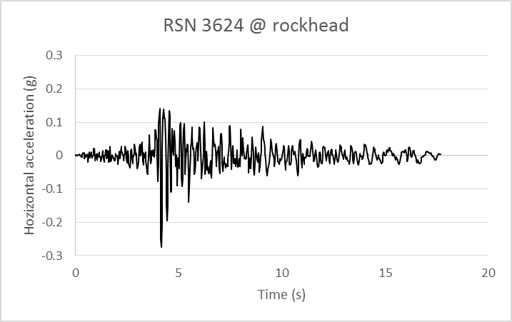
Figure 4: Example of horizontal acceleration plots at base of model (left) and rockhead (right) for earthquake record RSN479.
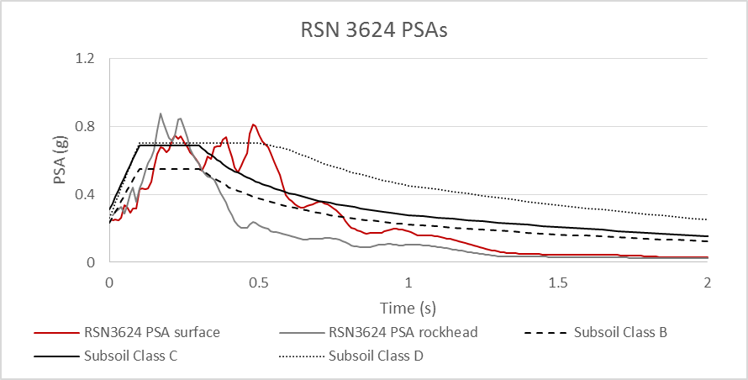
The pseudo spectral acceleration (PSA) at both rockhead and surface have then been compared against the traces for Subsoil Classes B, C and D, as presented in Figure 5. The PSA from PLAXIS has been determined for a damping ratio of 5% and a maximum period of 2s and it shows that the chosen amplification factors are consistent with a subsoil Class B design spectrum at rockhead, and a subsoil Class C design spectrum at surface.
Figure 5: Example of measured PSA at surface and rockhead for earthquake record RSN3624

Outputs of the dynamic analysis
As outlined by Neves and Naylor (2020) in their simplified design approach for this sort of problem, there are two crucial inputs that impact on their proposals (both validated as part of the dynamic FE analysis):
- Depth of evacuation – which controls the post-earthquake retained height and, although it can be initially estimated using LE pseudo-static models, may require numerical modelling depending on the importance level of the structure to design and the projected post-evacuation profile.
- Soil block movement – which informs the lateral soil displacement profile and its magnitude, thus governing the stresses the shear piles are subjected to.

Depth of evacuation
The dynamic analysis has corroborated that, throughout the design seismic event, evacuation may occur on some of the cross sections of the proposed palisade wall. This will naturally contribute to a reduction in lateral support and increased pile deflections, which corroborates the original assumption in Neves and Naylor (2020) that the palisade wall acts as a flexible system. Therefore, it is appropriate to adopt yield accelerations within the displacement compatibility procedure of the proposed simplified design approach, as opposed to considering full seismic load.
On the other hand, the depth of evacuation has also been found to be heavily dependent on the subsoil material properties. In fact, for the two different scenarios described in Section 2.1, entirely different depths of evacuation have been estimated, with larger values derived for fully liquefied/cyclic softened conditions. Table 2 summarises the depth of evacuation and maximum horizontal deflection of the palisade wall at one of the design sections.
Table 2: Summary of total displacements in front of the seawall and associated depths of evacuation for the design cross section.
Earthquake records | Maximum total displacement in front of palisade wall [mm] | Depth of evacuation from top of palisade wall [m]
Full strength soil properties
RSN479 | <600 | 0.1
RSN3624 | <600 | 0.1
RSN3861 | <600 | 0.1
Fully liquefied/cyclic softened soil properties
RSN479 | <3600 | 2.6
RSN3624 | <2400 | 1.7
RSN3861 | <9600 | 3.2

The values in Table 2 represent upper and lower bound limits, with the true behaviour of the system to be somewhere within those boundaries. Therefore, for this particular cross section an average depth of evacuation of 2m below top of palisade wall has been considered in the simplified design approach. This has been based on the overall geometry and stratigraphy at this location, as well as the existing seawall foundation level and embedment.

Soil block movement and pile lateral deflection
As discussed in Neves and Naylor (2020), a few adaptations have been proposed to the common practice design methods for shear piles resisting lateral spread. These typically ensure displacement compatibility between the displaced soil mass and the mobilized pile resistance by:
- Combining the Newmark Sliding Block theory and Limit Equilibrium analysis to predict the permanent soil displacements, depth of failure and yield accelerations of the slope; and
- Use of specialized piling/retaining wall software (e.g. LPILE or equivalent) to ensure displacement compatibility is reached.
The proposed modifications in Neves and Naylor (2020) relate to the adaptation of the above general method to a scenario where lateral movement is combined with evacuation. The modifications include the choice of soil springs along the evacuated soil depth, as well as the shape of the lateral soil movement profile to use in the shear pile design. Instead of assuming that full lateral displacement takes place above the liquefied layer, decreasing linearly to zero (MBIE, 2016), Neves and Naylor (2020) propose to use an equivalent linear variation soil block displacement profile, with the same average value as determined by the Newmark Sliding Block analysis. The FE analysis results have been used to validate this proposal, with Figure 6 summarising the soil block movement, as well as pile lateral deflection profiles, from both simplified approaches and FE analysis.
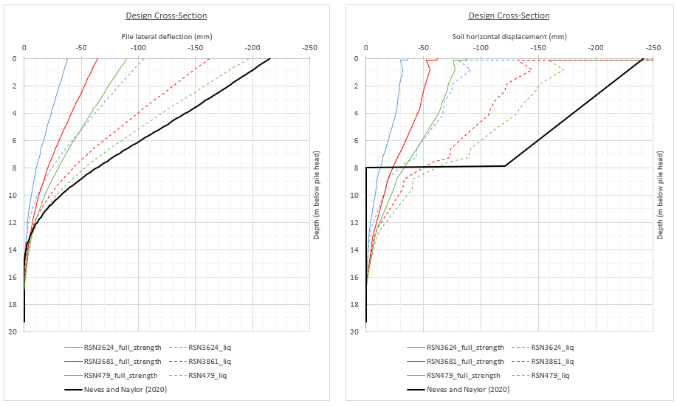
Figure 6: Soil block movement and pile lateral deflection profiles for full strength and fully liquified/cyclic softened conditions (time history analysis) versus simplified design approach from Neves and Naylor (2020).
Note that results for both subsoil conditions (full strength and fully liquified/cyclic softened) are reported for completeness. Naturally, larger soil block displacements and pile deflections are reported for fully liquified/cyclic softened conditions. The soil block displacement estimate has been measured 1.0m behind the proposed palisade wall within the PLAXIS models.

Comparison of simplified design procedure versus dynamic analysis
The plots on Figure 6 present the outcomes of the FE dynamic analysis as well as the simplified design approach proposed by Neves and Naylor (2020). The latter makes use of the alternative lateral soil movement profile, which varies linearly with depth, albeit with the same average value as the Newmark Sliding Block estimates.
The comparative exercise suggests that the proposed simplified approach agrees reasonably well with dynamic analysis in terms of pile deflections, albeit forecasting higher soil block displacements. This is thought to be the result of PLAXIS 2D not allowing for soil elements to extrude past the proposed palisade wall, which therefore limits the magnitude of displacement captured by the software.
In terms of pile structural forces, the results of the simplified approach (Neves and Naylor, 2020) also agree well with the envelop of structural forces (shear and bending) derived in the FE modelling (Figure 7).
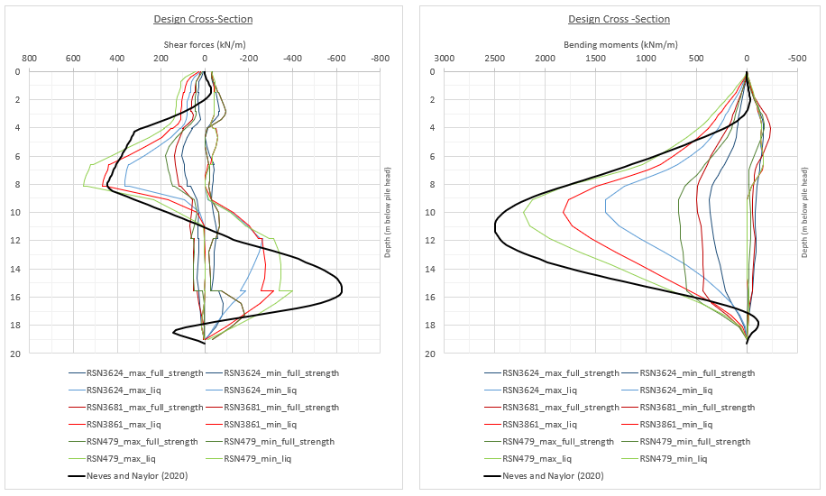
Figure 7: Shear forces and bending moments for full strength and fully liquified/cyclic softened conditions (time history analysis) versus simplified design approach from Neves and Naylor (2020).
As anticipated, larger stresses are obtained in the FE analysis when considering fully liquified/cyclic softened subsoil conditions. These are perceived as an upper bound of the forces acting on the piles and are a good match to the results of the simplified design approach, which is therefore deemed fit for design purposes.

CONCLUSION
It is generally accepted that the modelling of the lateral load transfer mechanism between pile and soil, in the case of a lateral soil displacement problem (e.g. lateral spread), is best approximated by specialist pile analysis software that can capture the non-linearity of this interaction. However, such software is unable to also monitor the general ground and nearby structures’ response during a seismic event, which is particularly relevant when the asset to protect is located at ground and/or near surface, behind the proposed retaining system.
Therefore, the reliance on time-history modelling not only offers a greater amount of meaningful information but can also result in significant overall construction savings for large scale and/or high importance level projects. Nevertheless, these analyses are not only considerably more time and resource consuming, but also require a thorough understanding of the existing ground conditions, which is very unlike to fit in with the programme and budget restrictions of a typical civil engineering project.
For the latter, a suitable design can be achieved when using the design procedure highlighted in Neves and Naylor (2020), although a careful selection of the material parameters in LPILE (or equivalent) may be required, as the default values may not yield a satisfactory answer. For large scale and/or high importance level projects, the simplified procedure should still be used to help calibrate and validate the time-history analyses.

ACKNOWLEDGMENTS
The authors are grateful to the assets’ owner, Auckland Transport, for their permission to prepare this paper.

REFERENCES
Auckland Council. 2020. Auckland Council GeoMaps. Available at https://geomapspublic.aucklandcouncil.govt.nz/ viewer/index.html. Accessed on 16/04/2020.
Idris, I. and Boulanger, R. 2008. Soil Liquefaction During Earthquakes. Monograph Series, No. MNO-12, Oakland, USA: Earthquake Engineering Research Institute.
Neves, M. and Naylor, A. 2020. Simplified design procedures for shear piles subject to liquefaction induced lateral spread with evacuation. Proceedings of the New Zealand Society of Earthquake Engineering (NZSEE) Annual Conference. Wellington, New Zealand: NZSEE.
Neves, M., Yang D, Child M. and Lai, T. 2020. Time-history validation of pseudo-static design procedure for jet grout shear walls subject to liquefaction induced lateral spread. Proceedings of the New Zealand Geotechnical Society (NZGS) 2020 Symposium. Dunedin, New Zealand: NZGS.
New Zealand Transport Agency (NZTA).2016. Bridge manual - manual number: SP/M/022 3rd Edition, Wellington, New Zealand: NZ Transport Agency.
Robertson, P. and Wride, C. 1998. Evaluating cyclic liquefaction potential using the cone penetration test. Canadian Geotechnical Journal, Volume 35, pp.442-449, Ottawa: Canada: Canadian Science Publishing

