Performance of road networks in the 2016 Kaikōura earthquake: observations on ground damage and outage effects

D Mason, P Brabhaharan & G Saul
Opus International Consultants Ltd
Doug.Mason@opus.co.nz (Corresponding author)

Keywords: Earthquake hazards; Road networks, Fault rupture; Landslides; Embankments; Retaining walls; Bridges

Abstract

The 14 November 2016 M_{w} 7.8 Kaikōura earthquake triggered thousands of large landslides and caused severe disruption to the state highway and local road network in the North Canterbury and Marlborough regions. Damage to the network included landslides, debris flows, rock falls, failure of retaining walls, and slumping of embankments, including minor damage from liquefaction and lateral spreading. Landslides and embankment failures caused the most damage and disruption to the transportation infrastructure, particularly where the cumulative effect of large landslides along narrow road corridors through steep inaccessible terrain lead to restricted access for plant and equipment and consequently resulted in very long road outage times. Surface fault rupture also caused closure of the roads, but access was quickly reinstated by formation of ramps or repairs to the pavement. Failures of low height cut slopes were able to be cleared quickly and only caused short term closure of the road. Extensive slumping of low height embankments commonly reduced the available lane width but the damage was quickly reinstated by temporary repairs of the damaged sections. Damage to some bridges occurred in the earthquake, but most bridges were able to be opened quickly with restrictions or bypassed with alternative crossings. Settlement at bridge abutments was widespread and in some cases prevented access over the bridges until temporary ramps could be formed.

Introduction

Road networks provide a vital lifelines function to society, and their availability is critical for emergency response and recovery after major hazard events. A severe magnitude 7.8 earthquake struck 15 km north-east of Culverden in the South Island of New Zealand, at 12:02 am on Monday 14th November 2016. This was followed by numerous aftershocks. At least 21 faults ruptured on and offshore of the north-east of the South Island of New Zealand. The ruptures began on The Humps Fault near Culverden and continued north-eastwards for ~180 km (Stirling et al., 2017).

The earthquake caused widespread damage across the northeast of the South Island. In particular, fault rupture, strong ground shaking, and co-seismic landslides severely damaged road networks, including State Highway 1 (SH1) between Ward and Cheviot and other local roads in the Kaikōura and Marlborough districts. This paper provides a summary of the observed ground damage along the road networks in North Canterbury and Marlborough, and the impacts these had on availability of access during the immediate phase of emergency response.

Ground shaking

The ground motions were recorded by Geonet seismographs in the upper South Island, with the largest horizontal peak ground accelerations being recorded at the Ward Fire Station (1.27g) and the largest vertical ground acceleration being recorded in Te Mara Farm in Waiau (3.22g), although this record may have been contaminated by other effects (Kaiser et al., 2017). The relative magnitudes of the accelerations and the MM intensities are shown in Figure 1.

Ground shaking was strongest in the epicentral region near Culverden, and to the northeast between Kekerengu and Seddon. The strong shaking near Ward is possibly due to the southwest-to-northeast earthquake rupture sequence directed towards this part of the South Island (Kaiser et al., 2017). The ground shaking attenuated rapidly towards the south, with minimal shaking south of Amberley (57 km south of epicentre).

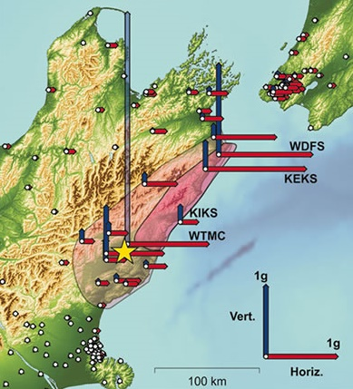  A | 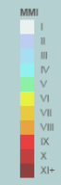  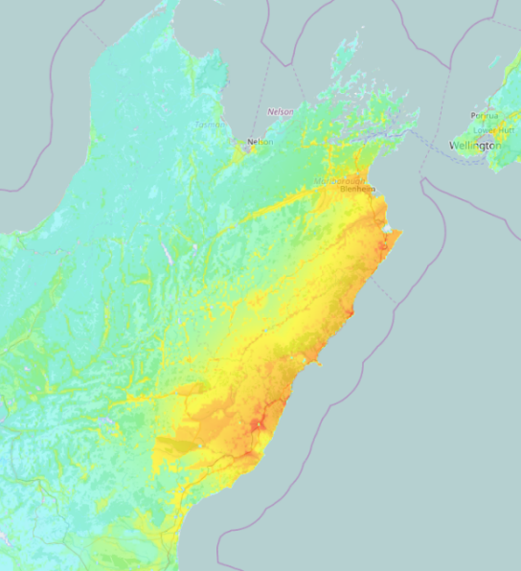  B

Figure 1. (A) Ground accelerations in the Kaikōura earthquake, with the extent of mapped landslides in the pink shaded areas (Source: https://www.gns.cri.nz/Home/News-and-Events/Media-Releases/strongest-ground-shaking-in-NZ. (B) Modified Mercalli Intensity of shaking in the Kaikōura earthquake (Source: http://shakemap.geonet.org.nz/mapping/2016p858000.html

Road closures

The state highway network in the upper South Island is shown in Figure 2. Immediately following the earthquake, SH1 was closed between Waipara and Wairau River township, and SH7 (including SH7A) was closed between Waipara and Springs Junction. Local roads were also closed, cutting off access to Kaikōura, Hanmer, and other smaller settlements in the region. By the end of 14 November, SH1 had reopened from Waipara to Cheviot and SH7 between Waipara and Springs Junction (Davies et al., 2017).

NZ Transport Agency contractors began to clear SH1 to Kaikōura from the south on 15 November, and army convoys began travelling on Route 70 in the first few days after the earthquake to deliver essential supplies to Kaikōura. Access for the convoys was subject to daily geotechnical inspection of the road conditions and geohazards. By 18 November, SH1 was open between Blenheim and Ward, and there was controlled access along SH1 between Cheviot and Goose Bay. SH1 between Ward and Clarence was opened on 12 December and between Cheviot and Kaikōura on 21 December (Davies et al., 2017).

SH1 between Clarence and Mangamaunu remains closed at the time of writing (August 2017) due to ongoing slip clearance and road repair works.

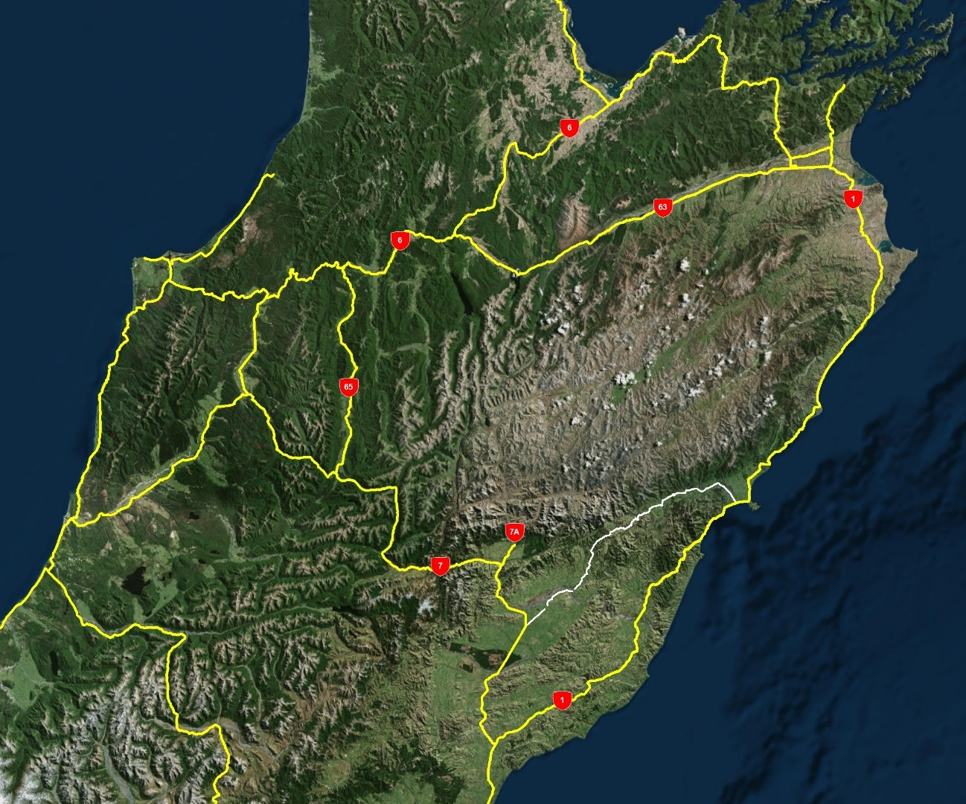
Hundalee
Mangamaunu
Clarence
Kekerengu
Seddon
Ward
Route 70
Waipara
Springs Junction
Culverden
Oaro
Blenheim
Kaikōura
Cheviot

Figure 2. Map of the regional state highway network in the upper South Island

Ground damage effects on roads

Widespread severe ground damage resulted from the earthquake, and was the major cause for the road closures. The following effects from the earthquake were observed during the immediate post-earthquake response in November 2016 as the principal causes of road closure:
- Fault rupture
- Landslides, cut slope failures and rock fall
- Embankment damage (including lateral spreading)
- Retaining wall damage
- Damage to bridges

Fault rupture

Surface fault rupture during the earthquake caused disruption to the road network in a number of places (Stirling et al., 2017). The extent of damage from fault rupture ranged from limited or small scale (<0.5 m) deformation of the road to large vertical displacement of 2-4 metres of the road surface. The most severe damage was caused by rupture of the Kekerengu and Papatea faults across SH1, where the damage was impassable and the road therefore was closed (Figure 3).

The outage time was limited, however, as access tracks were formed across the fault scarps by bulldozers within 1-2 days of the earthquake. Access across other fault scarps that had displaced the road was also quickly reinstated by forming gravel ramps over the faults.

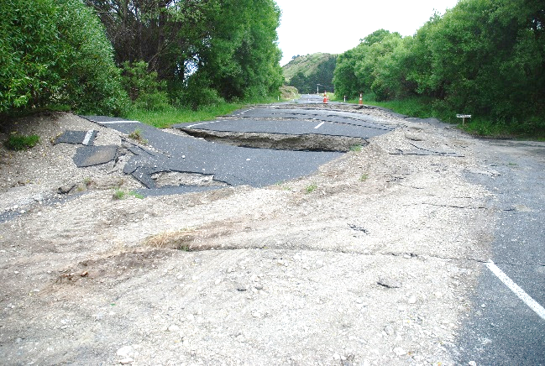  A | 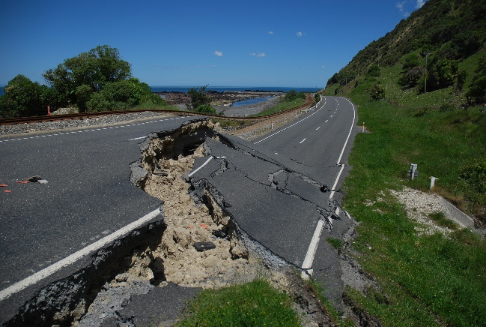  B

Figure 3. Examples of major damage to SH1 from fault rupture. (A) Rupture of the Kekerengu Fault near Tirohanga; ~2 m vertical displacement. (B) Rupture of the Papatea Fault at Mounsey Creek, Waipapa Bay; ~3-4 m vertical displacement.

Slope failures

Slope failures were the principal form of ground damage that caused prolonged closure of SH1 and other local roads. The types of slope failures along the roads and their impacts on road availability and outage times were influenced by the topography and road form.

Cut slope failures

Extensive cut slopes had been formed along SH1 between Ward and Okiwi Bay (south of Clarence) and between Oaro and Hundalee. These cut slopes were formed predominantly in weak Tertiary sedimentary rocks, overburden colluvium and alluvial terraces (Rattenbury et al., 2006). Cut slope angles ranged from about 45° to over 60°, and were predominantly of only modest heights of up to 20 m. These cut slopes suffered extensively from relatively shallow failures in the overburden and rock (Figure 4), particularly along SH1 between Ward and Clarence where nearly every cut slope had failed regardless of their height. This performance is considered likely to be due to the very high ground accelerations over 1 g recorded in this area (Figure 1).

Failure of cuttings was dominated by shallow translational sliding and wedge failures in the upper half of the cuttings, particularly in the Ward to Clarence area. This was likely due to topographical amplification of ground shaking and the presence of more dilated soil and rock masses in the upper parts of the cuts. Run-out from the failures of the upper half of the slope covered the lower half of the cuttings and encroached into the road depending on the height of these cuttings (Figure 4).

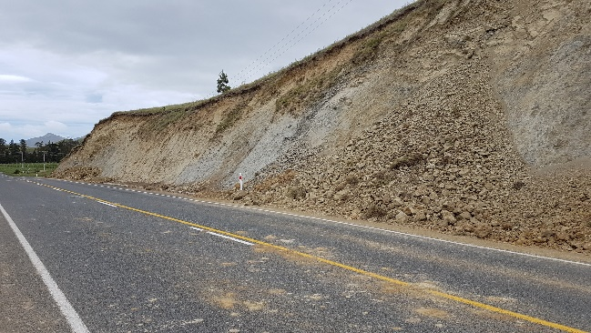  A | 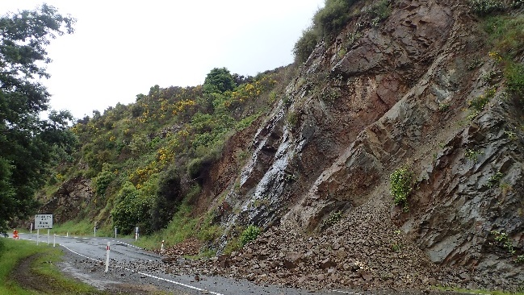  B

Figure 4. Examples of cut slope failures along SH1. (A) Failure of low height cutting in weak Tertiary siltstone, with accumulation of debris over the lower part of the slope. (B) Failure of cutting in indurated greywacke bedrock with encroachment of debris onto the road.
Given the limited height of these cuttings, the slip debris generally affected the shoulder and one half of the road, and where it affected both lanes, they were able to be partially cleared quickly to create at least one lane access.

Higher cut slopes in indurated greywacke bedrock, predominantly at the lower flanks of high hillsides were present along SH1 between Okiwi Bay and Mangamaunu (north of Kaikoura) and from Peketa to Goose Bay (south of Kaikoura). These cut slopes also suffered from extensive failures, predominantly shallow rock slides and wedge failures (Figure 4). However, the effects of cut slope failures in steep greywacke terrain were often insignificant in comparison to the larger failures of the natural hillslopes.

Landslides on natural slopes

Landslides on natural hillsides along the highway caused most of the prolonged road closures in the Kaikōura earthquake event. Along SH1, these landslides occurred predominantly between Okiwi Bay and Mangamaunu (north of Kaikōura) and from Peketa to Goose Bay (south of Kaikōura). Most of these landslides were soil and rock debris avalanches formed in both the overburden deposits as well as fractured and weathered rock. These failures mainly originated from the upper parts of the hillslopes, but given their size covered the lower slopes and completely buried the road below (Figure 5A). Topographical amplification and the presence of overburden and weathered and dilated rocks in the upper slopes are considered likely to have contributed to failure of the upper slopes.

Some large block slides also affected almost the full height of the slope and led to displacement of the slide mass onto the road below (Figure 5B). Defect-controlled rock slides were also observed in some areas, for example on Route 70 failure occurred by sliding on outward-dipping bedding planes in Tertiary sandstone (Figure 5C).

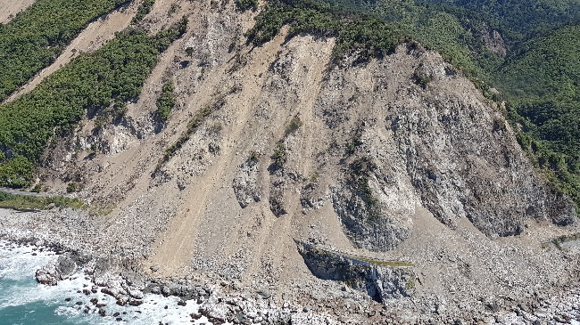  A | 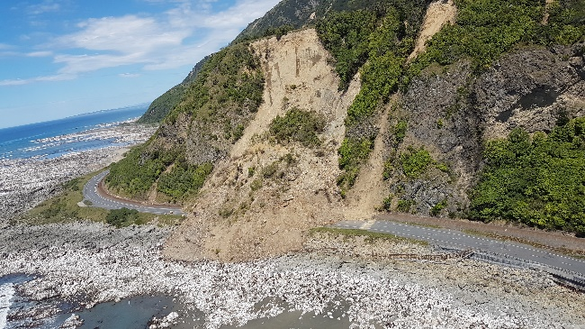  B
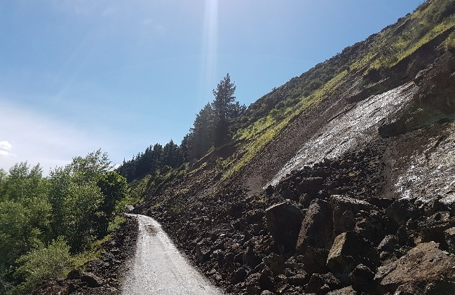  C | 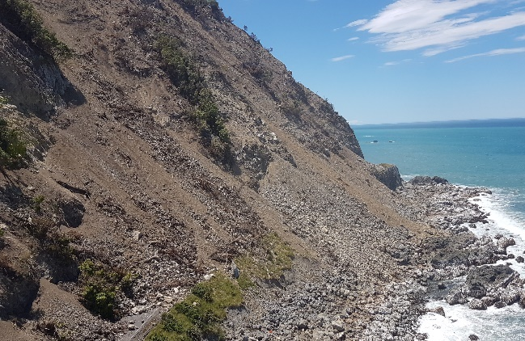  D

Figure 5. Examples of landslides on natural slopes. (A) Rock slides and debris avalanches originating at the tops of hillslopes and burying the road at the base of the slope. (B) Large block slide inundating the road. (C) Defect-controlled rock slide. (D) Complete burial of road by debris with large volumes of debris remaining on slope above.

These landslides were very damaging to the state highway and local roads, as they deposited large quantities rock and soil debris onto the road, and often large volumes of displaced debris with loose rock also remaining perched on the slopes posing ongoing safety hazards (Figure 5D), and led to long periods of outage where the road was closed. The section of SH1 between Clarence and Mangamaunu remains closed at the time of writing ~9 months after the earthquake while large landslides are cleared and the slopes stabilised.

Rock falls

Rock falls were observed along sections of highway where large landslides had occurred, as well as in areas without large scale failures. Rock falls often originated from cut slopes or steep bluffs above cuttings. Limited areas of rock slope stabilisation measures had been installed along the Kaikōura coast in the ~10-15 years before the earthquake, and these measures (generally consisting of rock bolts and mesh) generally performed well.

The potential for ongoing rock fall where the slopes have been loosened by the earthquake posed ongoing safety hazards to road users, and hence affected the ability to fully open roads for traffic without mitigation measures such as containers or earth bunds in place.

Embankments

Extensive damage was caused to earth embankments on SH1, particularly between Ward and Clarence and between Oaro and Cheviot, and on the inland Route 70. The predominant types of damage included cracking and deformation of the road surface, displacement and settlement of embankments, and displacement and failures of embankment slopes (e.g. Figure 6A). Damage to embankments in the Hundalees was often associated with reactivation of pre-existing landslide features, as well as settlement or displacement of the road where it crossed infilled gullies in the Tertiary mudstone bedrock (Figure 6B).

These features resulted in significant damage to the road, resulting in difficult access for the initial emergency response. However, the consequence was relatively minor, as slow access for 4WD vehicles was still available along the road, and the damage was quickly reinstated by repairs to the pavement and resurfacing of the damaged sections.

Localised sections of road embankment failure on SH1 and Route 70 were also closed or significantly damaged due to lateral spreading in recent alluvial/swampy deposits adjacent to waterways.

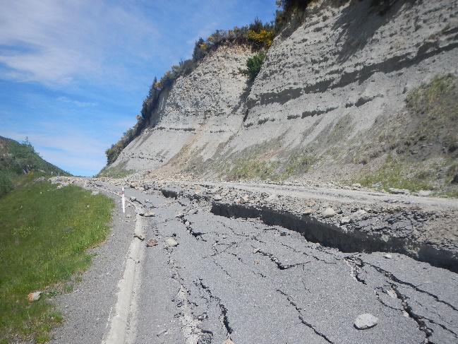  A | 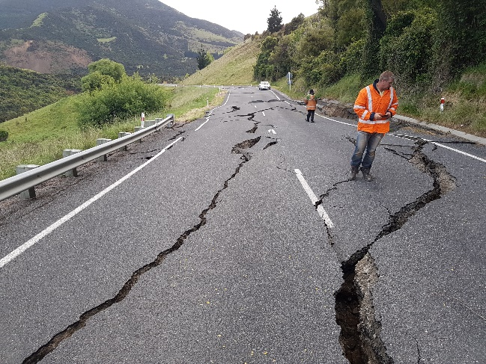  B

Figure 6. Examples of damage to embankments. (A) Large vertical settlement and spreading of an embankment slope on Route 70. (B) Displacement of SH1 embankment across an infilled gully in the Hundalees.

Retaining walls

Retaining wall structures which were tied back generally performed well, including gabion basket walls and timber pole walls up to 3 m to 5 m retained height. Gravity retaining structures generally performed poorly. These structures predominantly comprised gabion basket walls ranging in height from 1 m to 3 m height. Failure of the gabion basket walls was generally due to overturning, with a number of instances of translation observed. Pavement cracking and loss of shoulder support to the carriageway typically occurred at walls which exhibited this type of failure, with more severe damage to the wall or underslips resulting in loss of one lane (Figure 7).

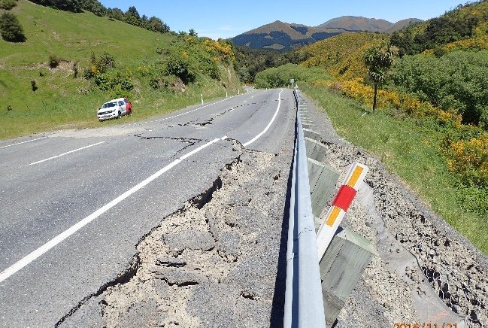  A | 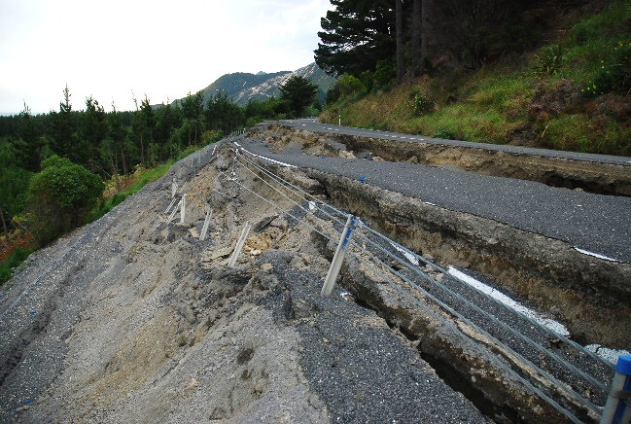  B

Figure 7. Examples of failure of gabion basket retaining walls. (A) Overturning failure. (B) Translational failure due to underslip.

Bridges

Many bridges suffered minor to moderate structural damage, predominantly pier plastic hinging, due to high ground shaking intensity (Palermo et al., 2017). Settlement at bridge abutments was widespread and in some cases prevented access over the bridges until fill or asphaltic concrete was used to form small ramps onto the bridges (Figure 8). Despite the widespread damage to bridges across the North Canterbury and Marlborough regions, most of the bridges were open for emergency access. Notable exceptions were the state highway overbridge over the railway lines at Oaro, which was able to be bypassed with a temporary level crossing, and the Wandle River bridge on Route 70, which was replaced by a bailey bridge.

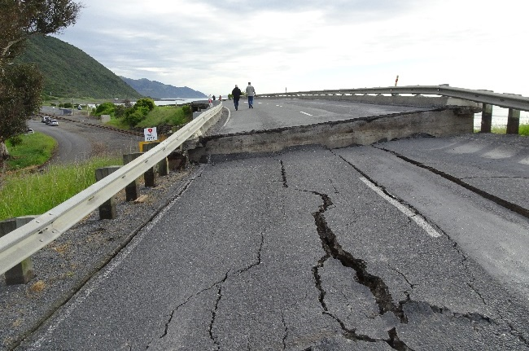  A | 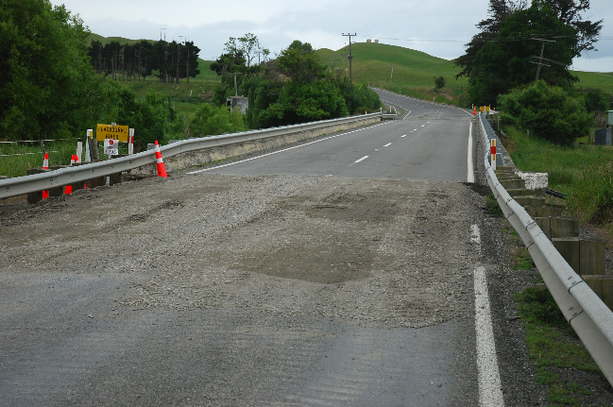  B

Figure 8. Examples of damage to bridges affecting road access. (A) The state highway overbridge at Oaro was closed due to >0.5 m of settlement at the approaches. (B) Access across bridges with less severe settlement was able to be quickly reinstated with temporary ramps.

Conclusions

The damage caused by the earthquake to the road networks provides valuable lessons on the impacts of large earthquakes on road performance and the duration of outage following such an event.

Landslides and embankment failures caused the most damage and disruption to the transportation infrastructure in the 2016 Kaikōura earthquake. Failures of low height cut slopes were able to be cleared quickly and only caused short term closure of the road, whereas landslides on high hillslopes extending 50 m to 100 m or more caused extensive damage and prolonged the closure. The unstable nature of the debris and the presence of disrupted rock masses along the slopes above the roadway made reconstruction efforts more difficult and involved a much longer duration for clearing of debris with sluicing, roped access scaling and careful formation of access to clear debris safely. Therefore the outage periods were much longer, such as on the coastal section of SH1 between Clarence and Mangamaunu.

Extensive slumping occurred of low height embankments between Ward and Clarence, and Oaro and Cheviot. This commonly reduced the available road or lane width but the overall consequence was relatively minor, as slow access for 4WD vehicles was still available along the roads and the damage was quickly reinstated by temporary repairs of the damaged sections. Similarly, surface fault rupture caused closure of the roads, but access was quickly reinstated by formation of ramps or repairs to the pavement.

Damage to some bridges occurred in the earthquake, but most bridges were able to be opened quickly with restrictions or bypassed with alternative crossings. Settlement at bridge abutments was widespread and in some cases prevented access over the bridges until fill or asphaltic concrete was used to form small ramps onto the bridges.

Acknowledgements

We wish to thank the team of geologists and engineers who were involved in the immediate emergency response for the road networks in North Canterbury and Marlborough for their urgent response and exceptional effort. The permission of NZTA and Marlborough Roads to publish the paper is also gratefully acknowledged.

References

Davies, A., Sadashiva, V., Aghababaei, M., Barnhill, D., Costello, S. et al. (2017) Transport infrastructure performance and management in the South Island of New Zealand, during the first 100 days following the 2016 M_{w} 7.8 “Kaikōura” earthquake. Bulletin of the New Zealand Society for Earthquake Engineering 50 (2): 271-299.
Kaiser, A., Balfour, N., Fry, B., Holden, C., Litchfield, N. et al. (2017) The 2016 Kaikōura, New Zealand, earthquake: Preliminary seismological report. Seismological Research Letters 88 (3): 727-739.
Palermo, A., Liu, R., Rais, A., McHaffie, B., Andisheh, K. et al. (2017) Performance of road bridges during the 14 November 2016 Kaikōura earthquake. Bulletin of the New Zealand Society of Earthquake Engineering 50 (2): 253-270.
Rattenbury, M., Townsend, D., Johnston, M. (2006) Geology of the Kaikoura area. Institute of Geological and Nuclear Sciences 1:250 000 geological map 13. 1 sheet + 70p. Lower Hutt, New Zealand. GNS Science.
Stirling, M., Litchfield, N., Villamor, P., Van Dissen, R., Nicol, A. et al. (2017) The M_{w} 7.8 2016 Kaikōura earthquake: Surface fault rupture and seismic hazard context. Bulletin of the New Zealand Society for Earthquake Engineering 50 (2): 73-84.

